**Method1: Manual**

* Create an Ec2 instance Launch ssh, ubuntu and connect to the git bash terminal.

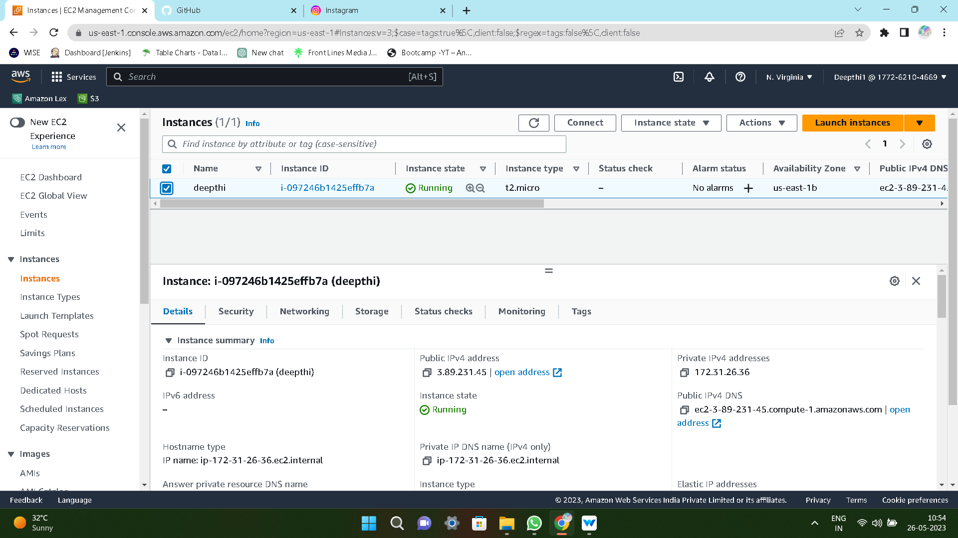

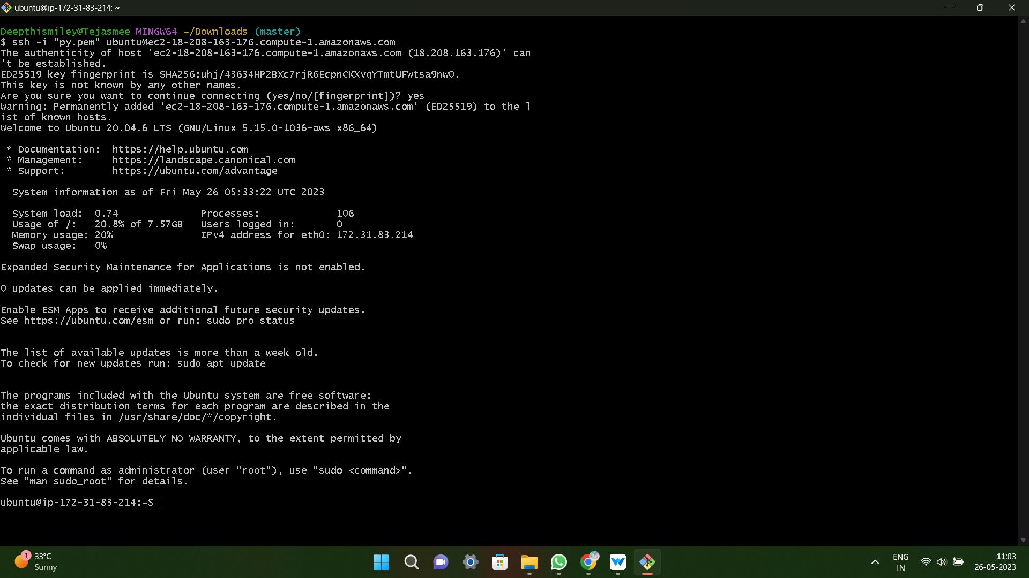

* Enter the commands like
* **Sudo apt update** you can use to keep all of your packages up to date in Ubuntu

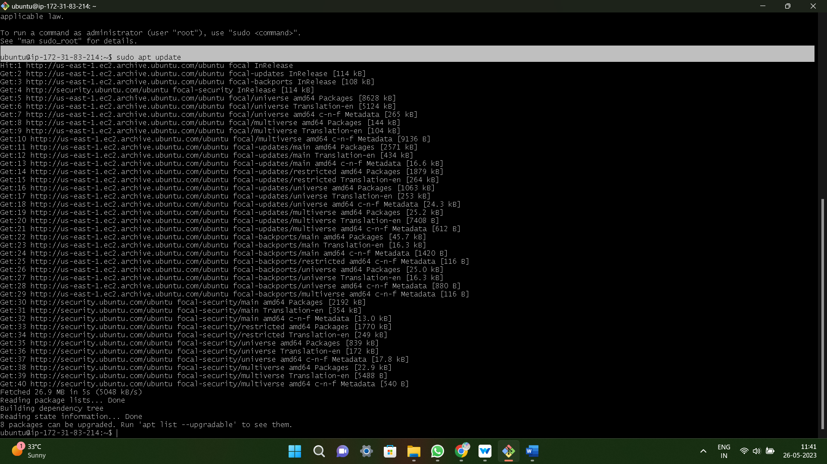

* **Sudo apt full-upgrade -y** command download and installs the update for each outdated packages and dependency on your system.

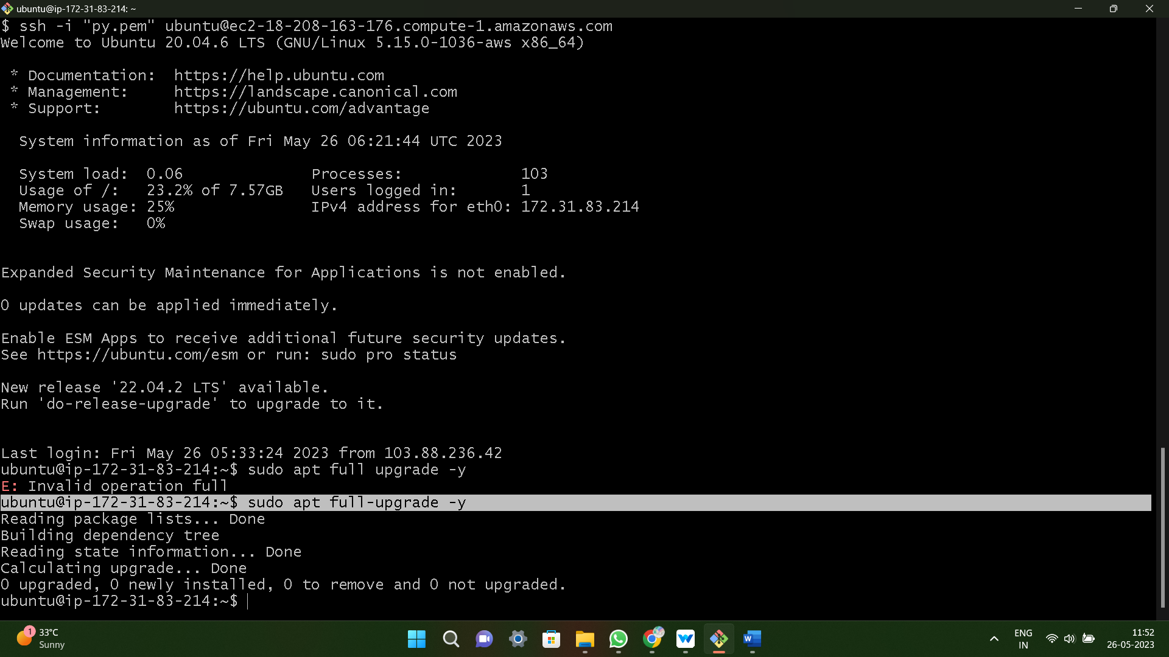

* **Sudo apt-get install python3-pip -y** is the command above will also install all the dependencies required for building python modules.

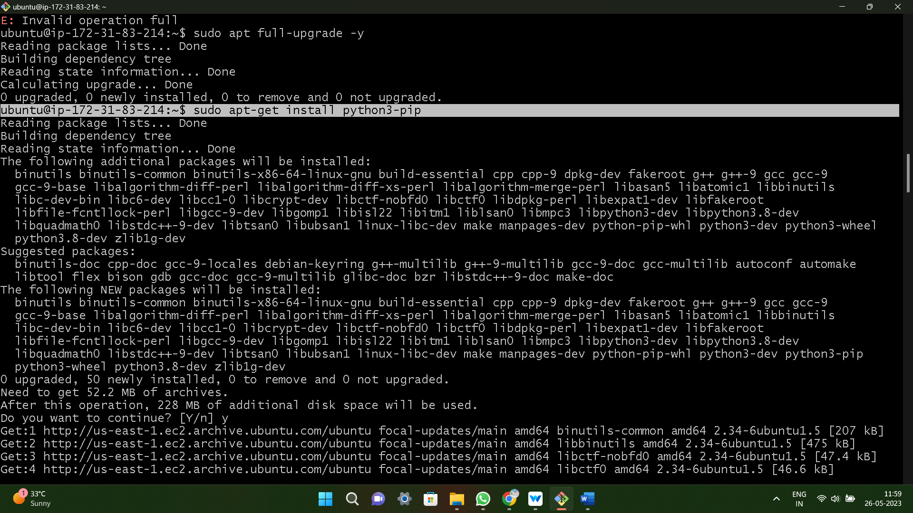

* **Sudo git clone <URL>** it coping repository

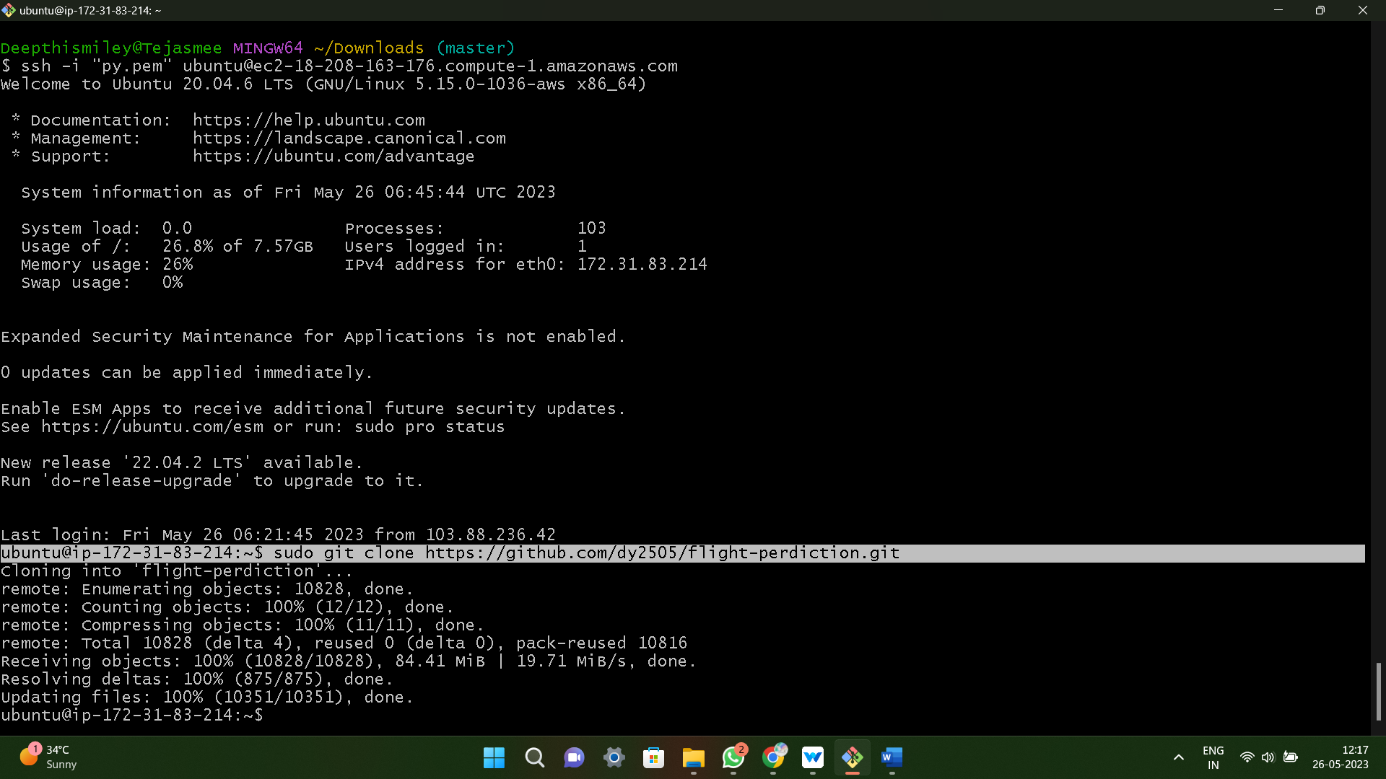

* **Pip3 install -r requirement.txt** is a text file that contains a list of pip packages with their versions that are required to run a specific Python project.

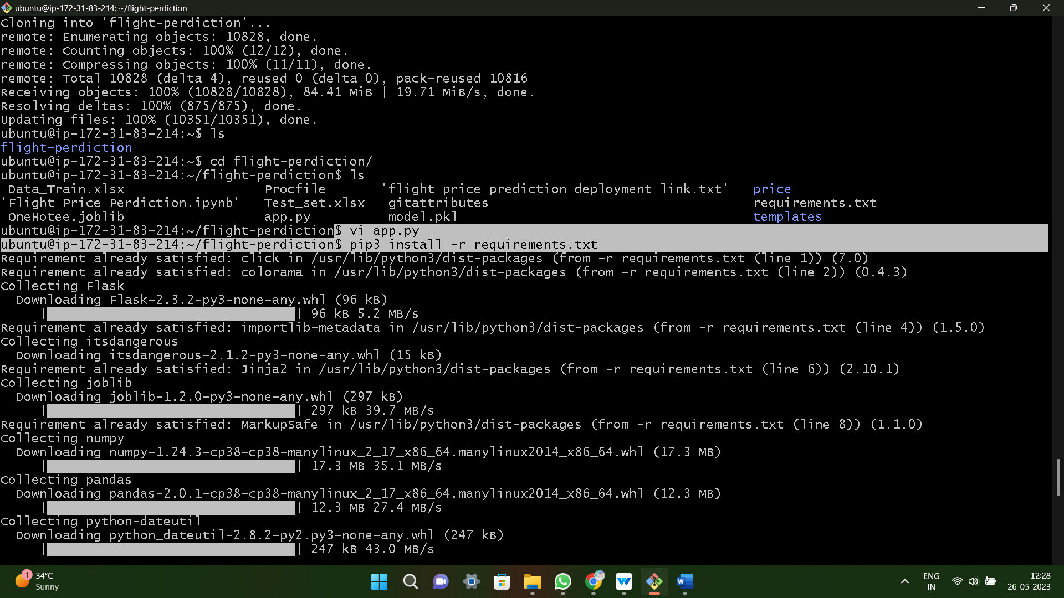

* **Sudo vi app.py**

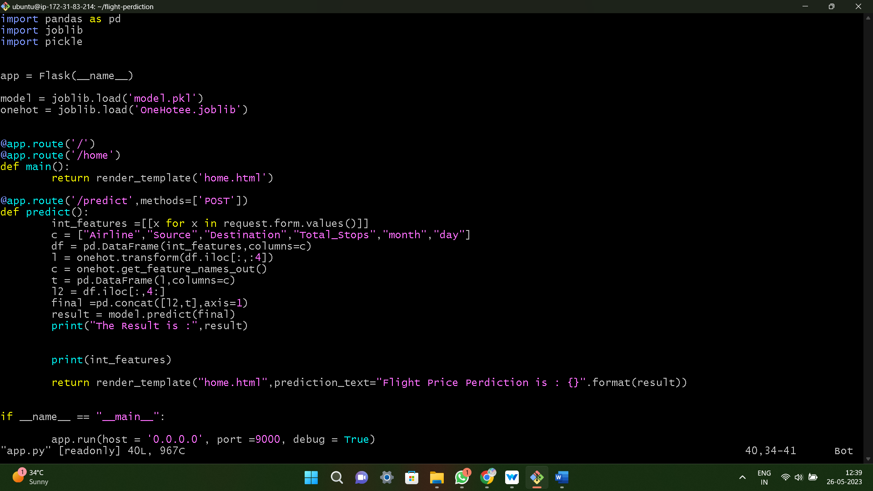

* **Python3 app.py**
* Copy public ip4 and paste it on browser it ip4:port

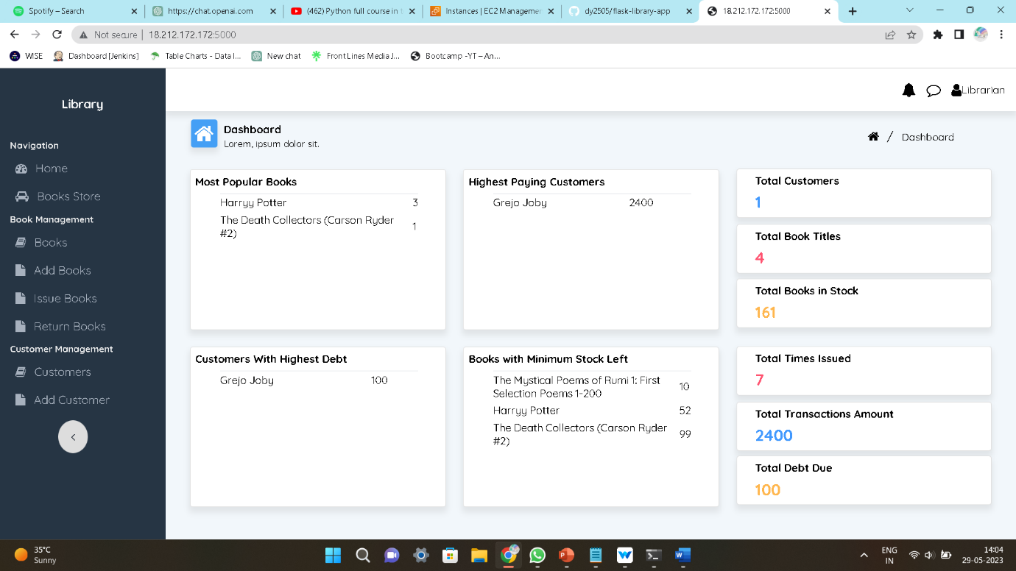

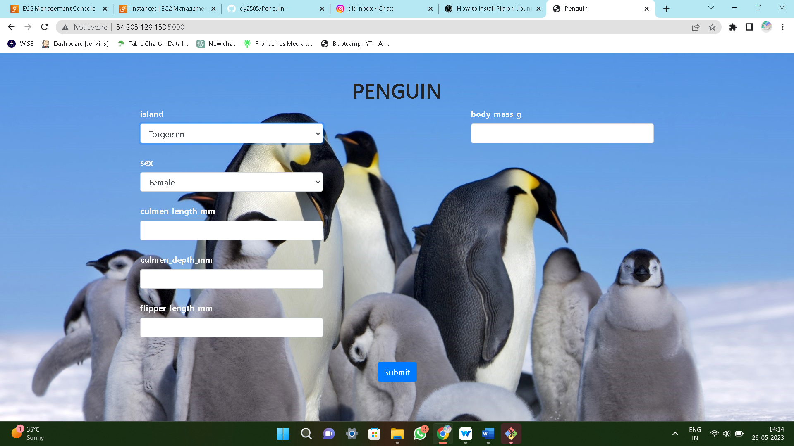

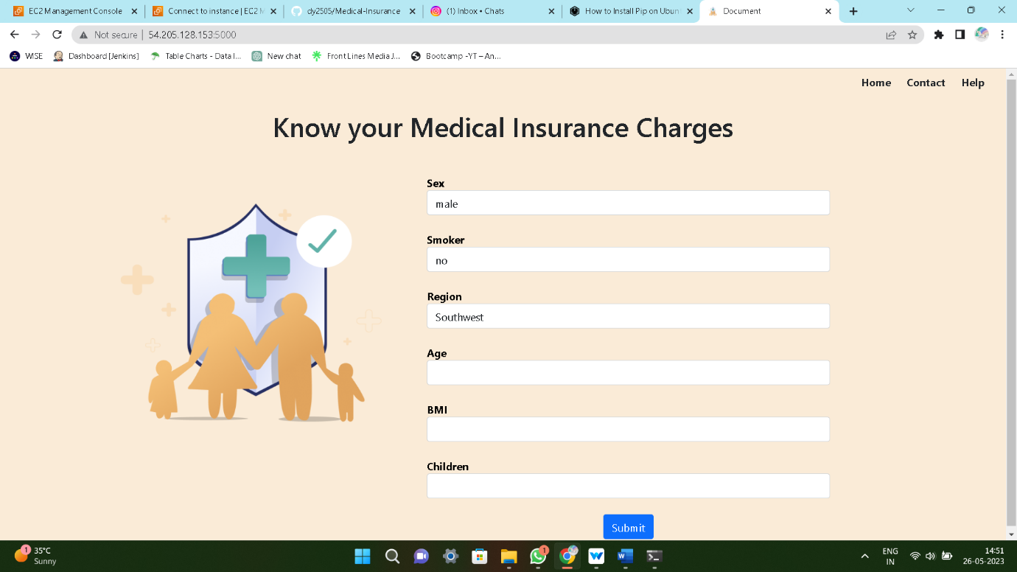

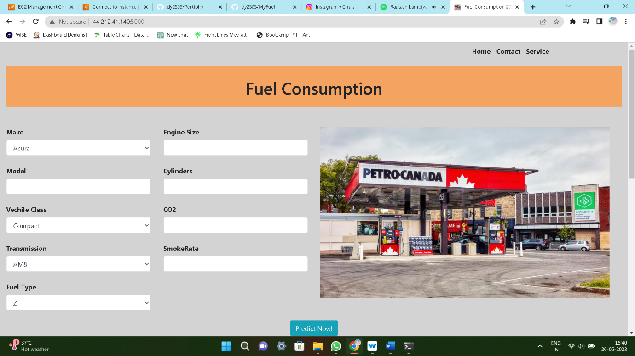







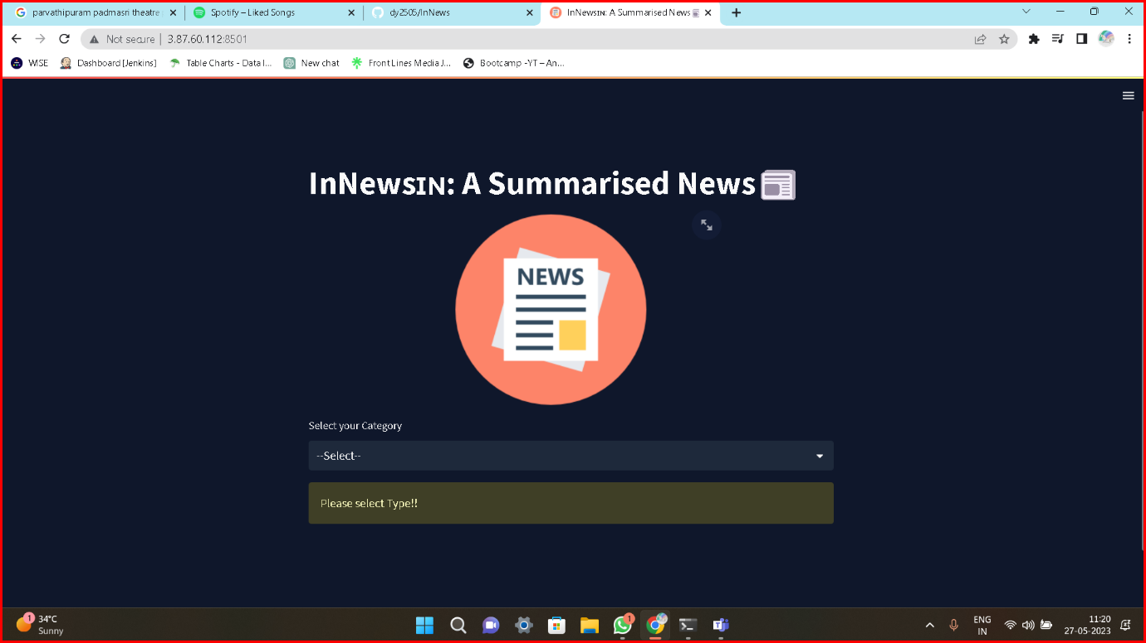

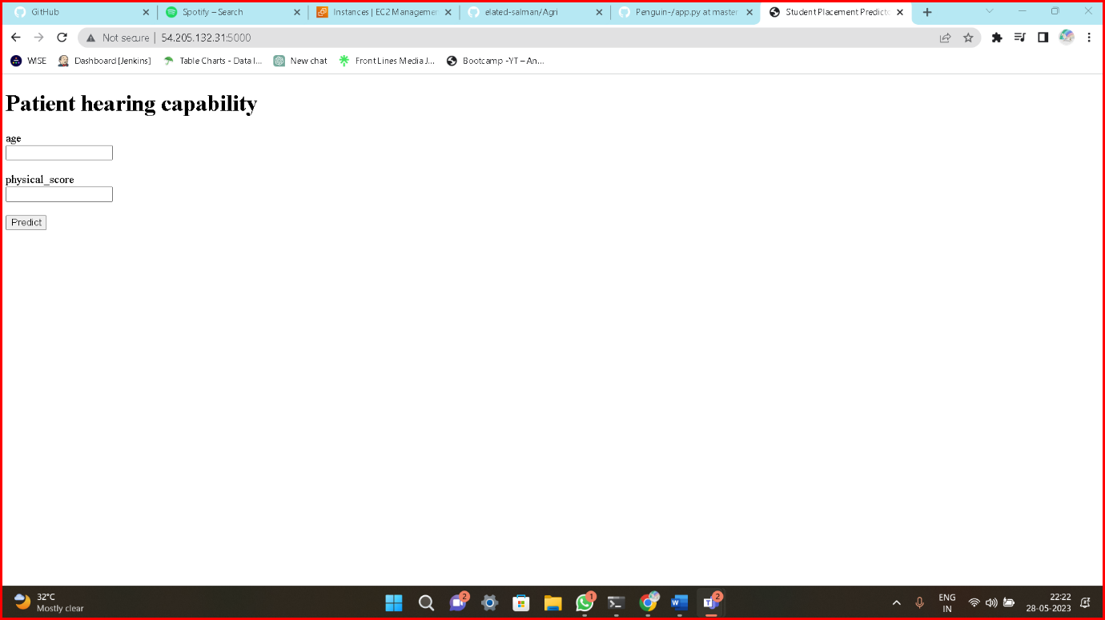

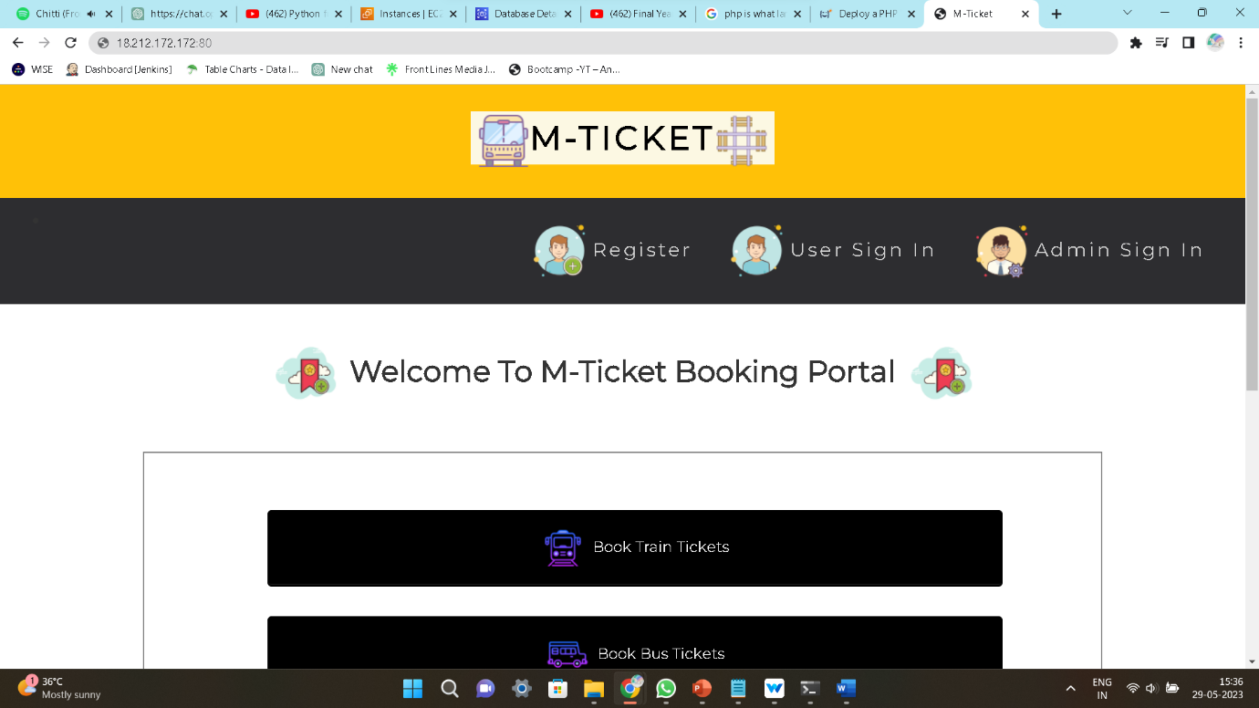

**Method2: Userdata**

* Create an Ec2 instance and give the all data in the userdata

1. **#!/bin/bash**
2. **Sudo apt update**
3. **Sudo apt upgrade -y**
4. **Sudo apt install python3-pip -y**
5. **Sudo git clone <URL>**
6. **Cd foldername**
7. **Sudo pip3 install -r requirements.txt**
8. **Sudo python3 app.py**

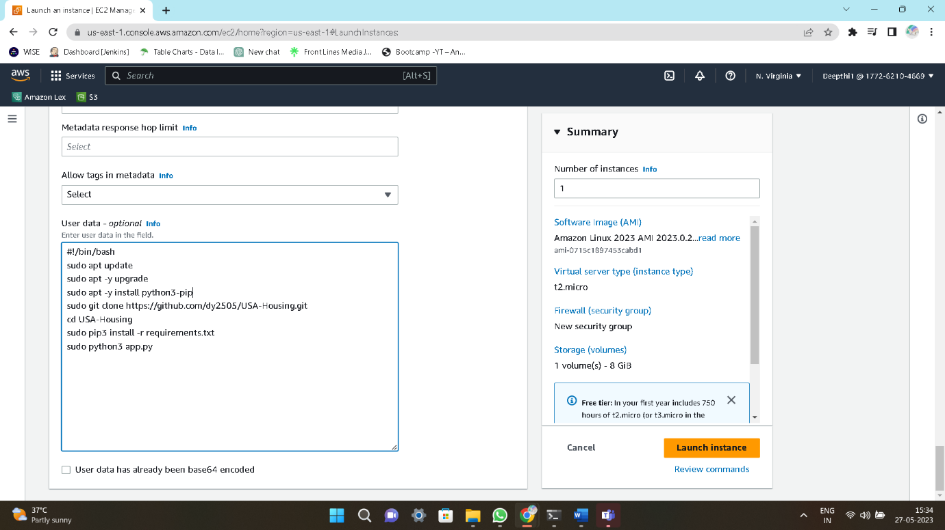

* After creating instance wait for initializing and check the status 2/2checkpass

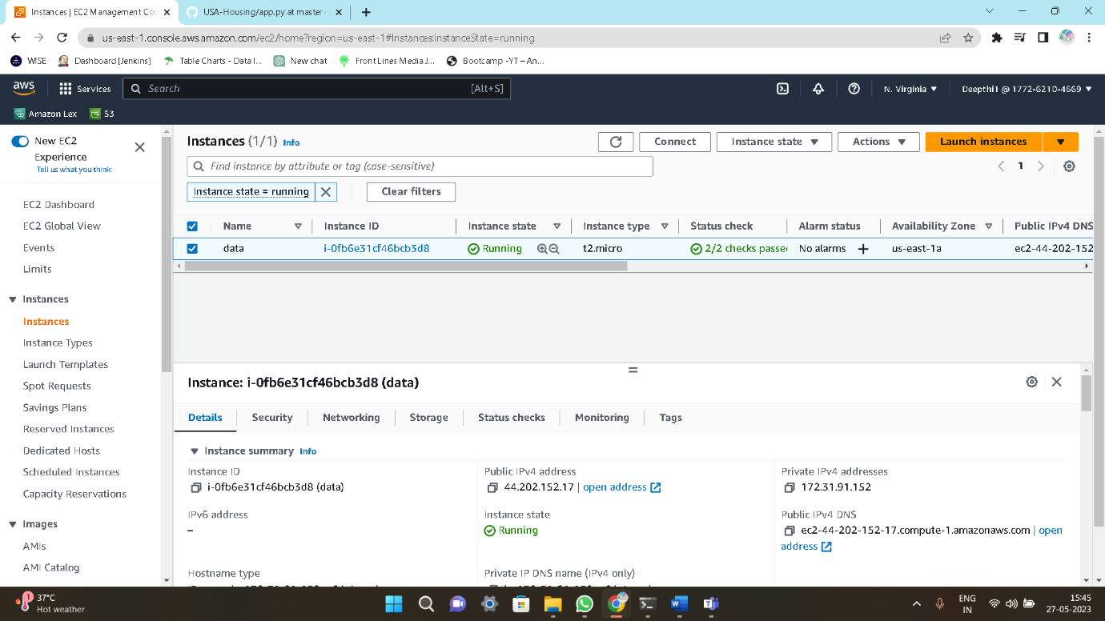

* Now edit the security group and give custom TCP and port number:5000, source anywhere

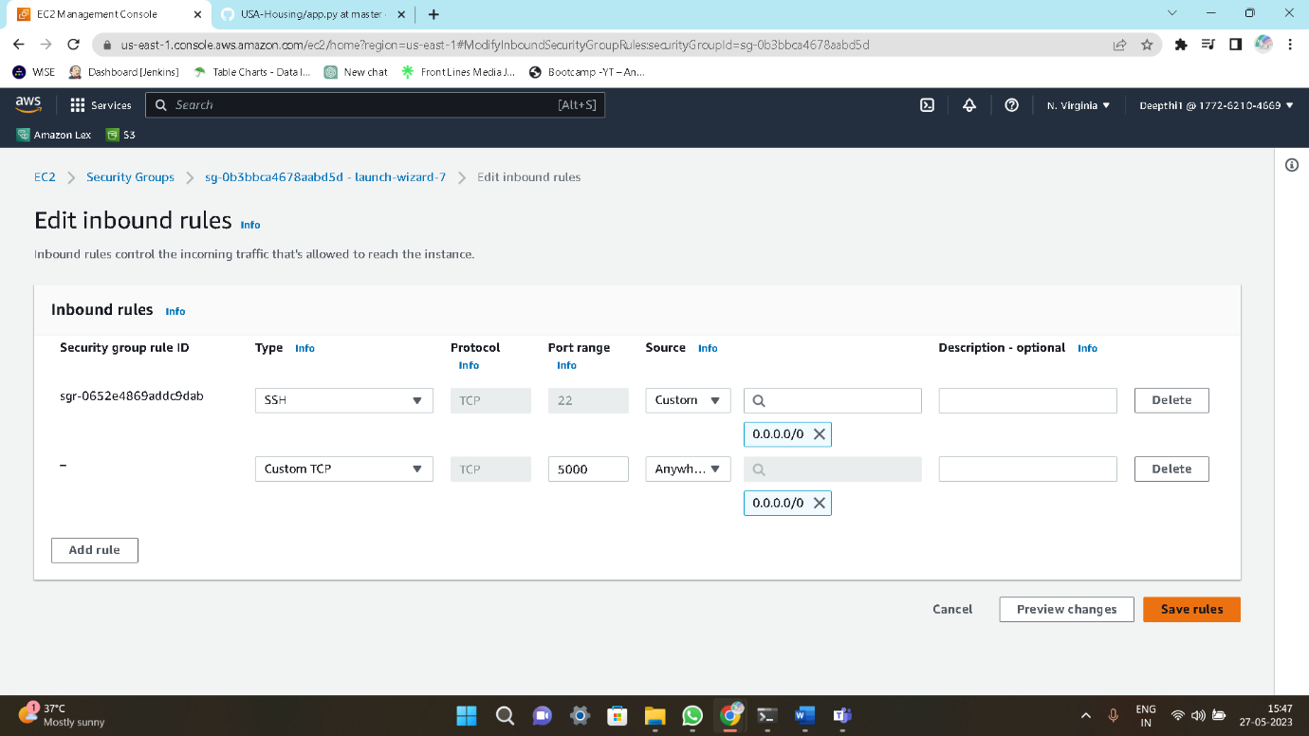

* Copy the public ip4 and browse it ip4:port



**Method3: Jenkins**

* Create an Ec2 instance , connect to the terminal and install Jenkins service and start and enable the service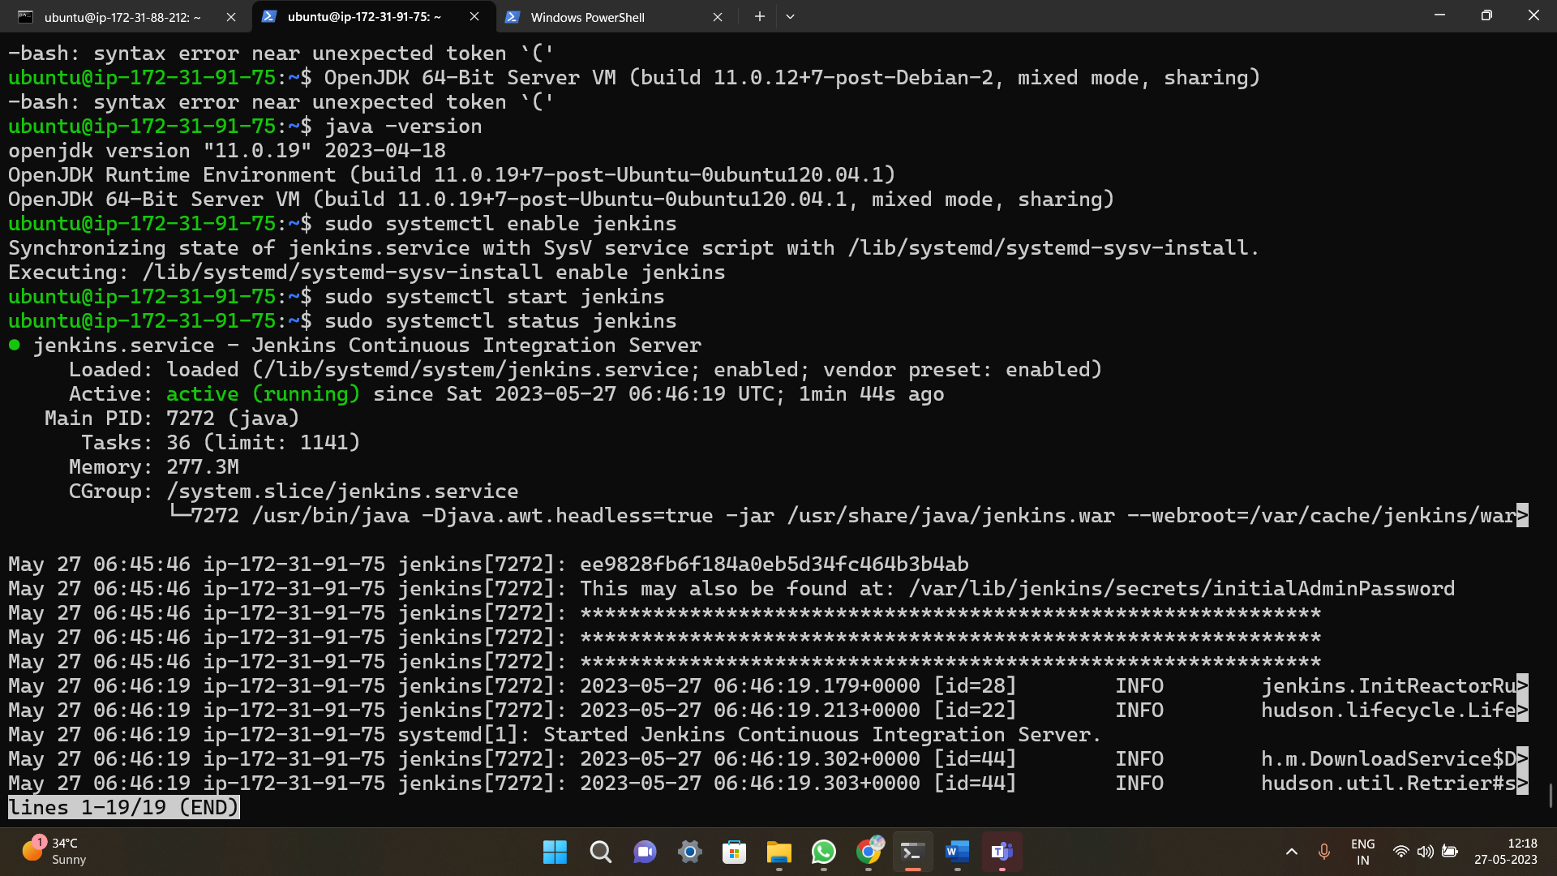

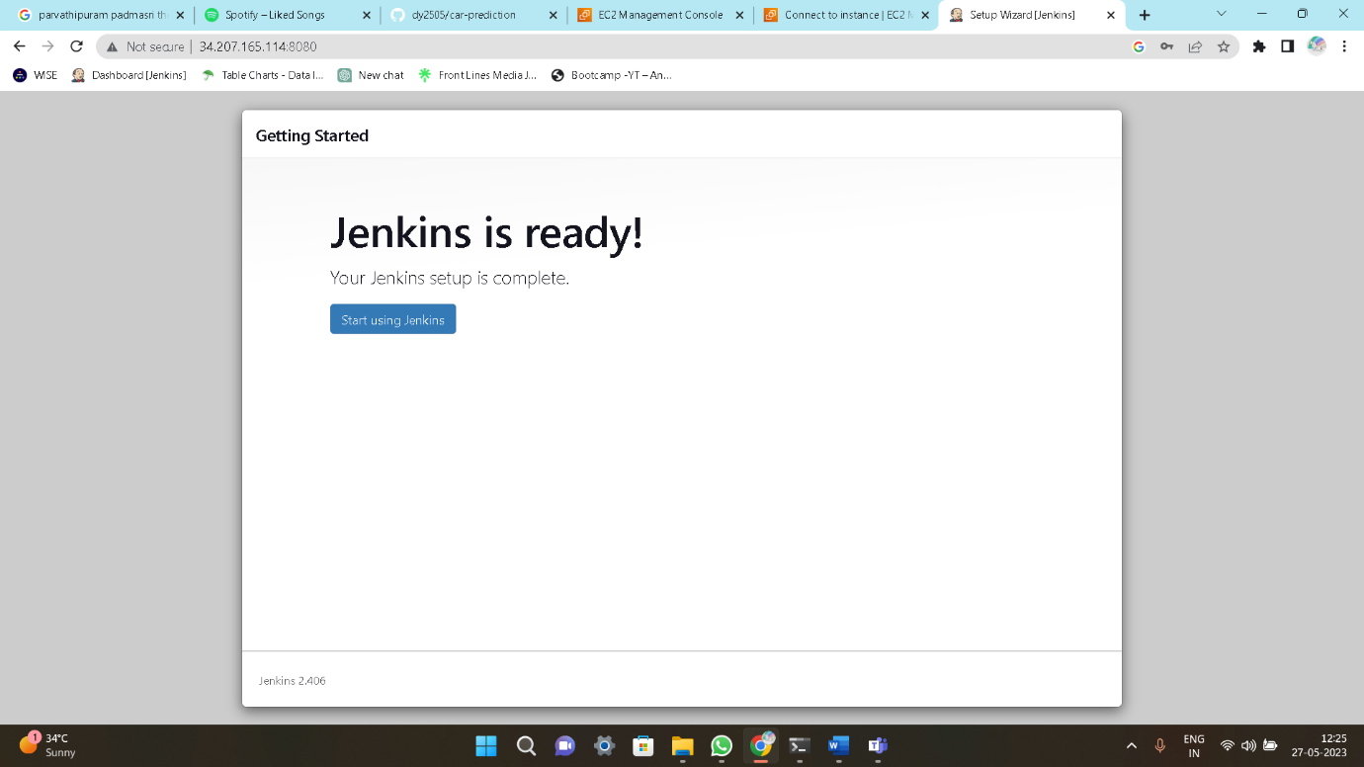

* Now create a free style project. in Build steps add some commands

1. **Sudo apt-get install python3-pip -y**
2. **Git clone <URL>**
3. **Cd foldername**
4. **Pip3 install -r requirements.txt**
5. **Python3 app.py**

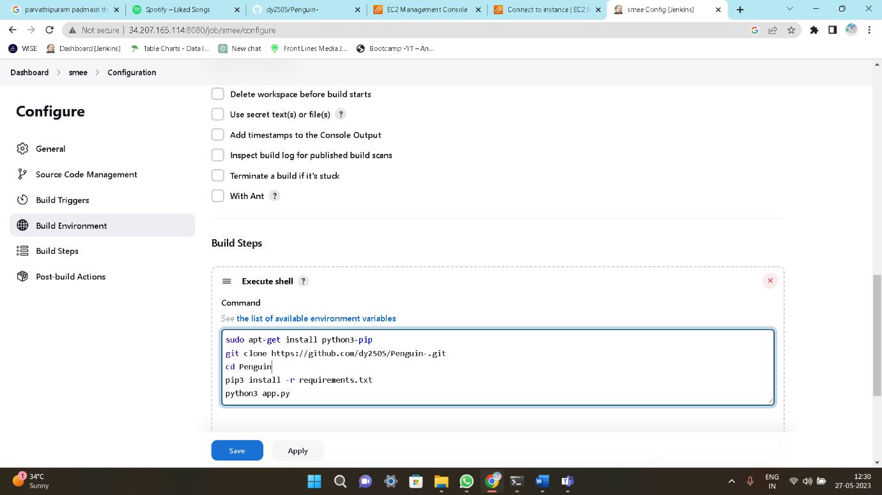

* Giving sudoers permissions , **jeniks ALL=NOPASS:ALL**

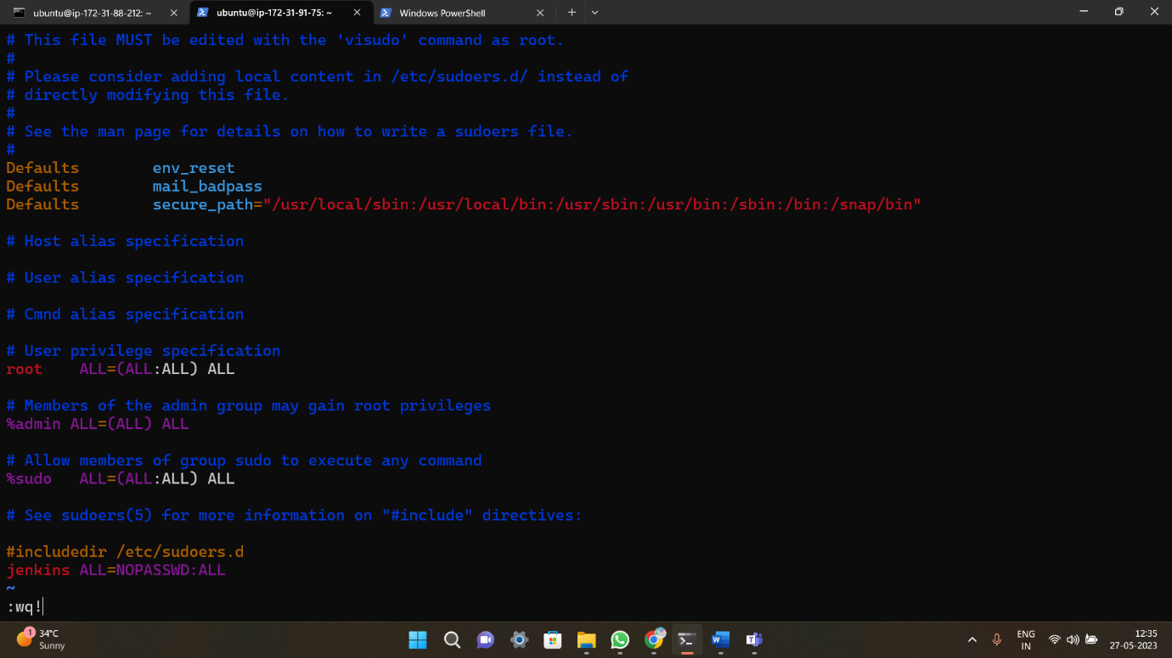

* After build, its successfully build now.

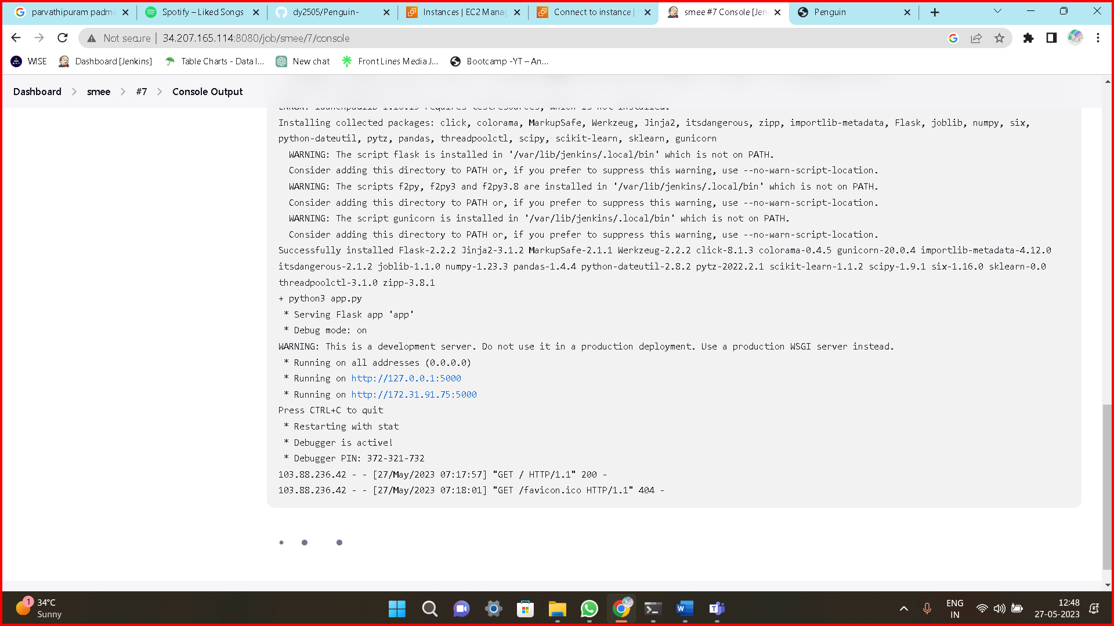

* Copy the public ip4 and browse it ip4:port

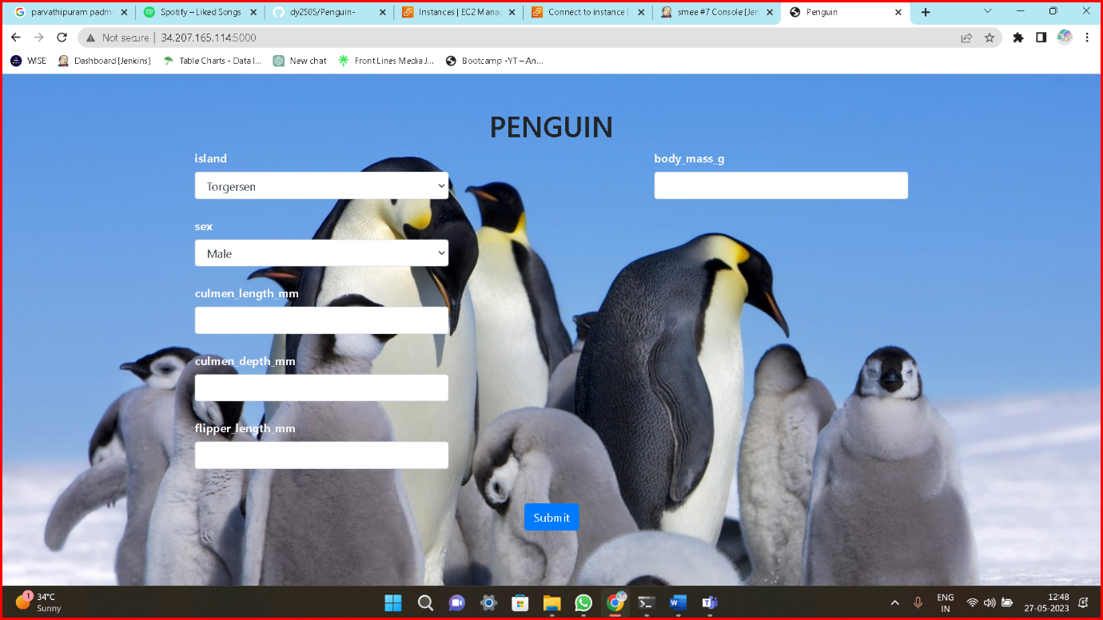

**Method4: Userdata.sh**

* Create an Ec2 instance and connect the terminal

1. Create a file by using **touch** command **touch userdata.sh**
2. Enter the data into the file **vi userdata.sh**

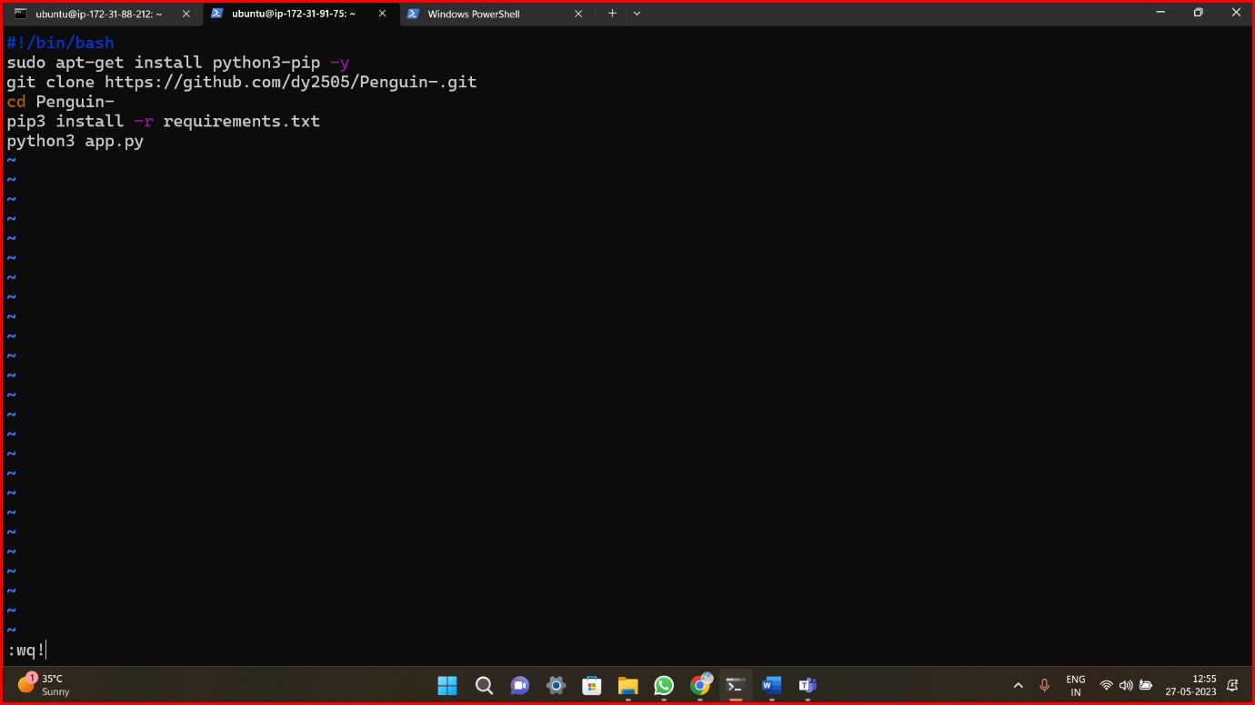

* Give execute permissions to userdata

1. **Chmod +x userdata.sh**
2. **./userdata**

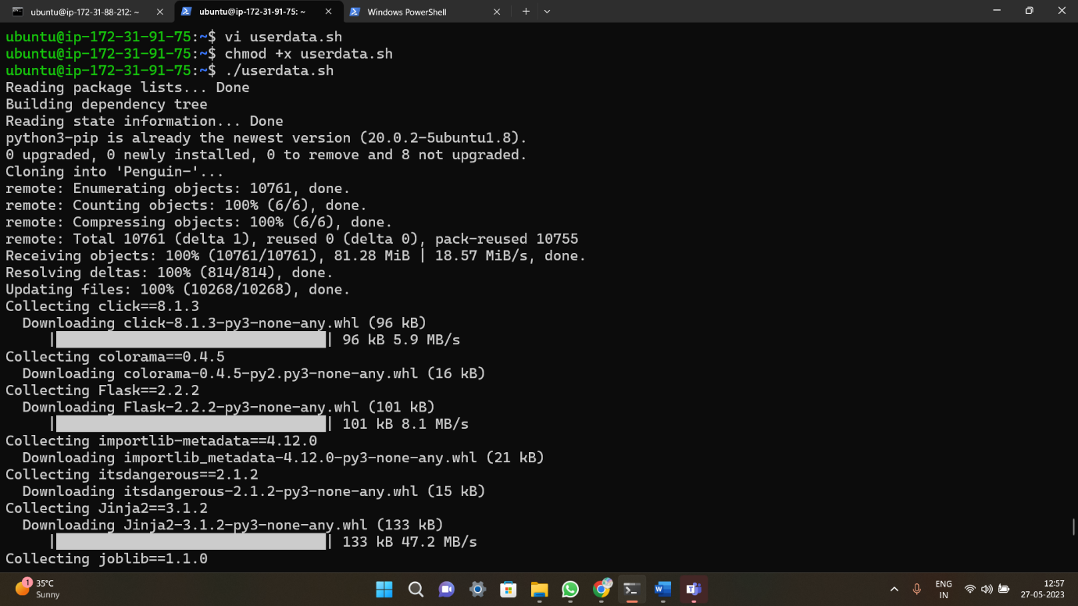

* Now its reading all the packages

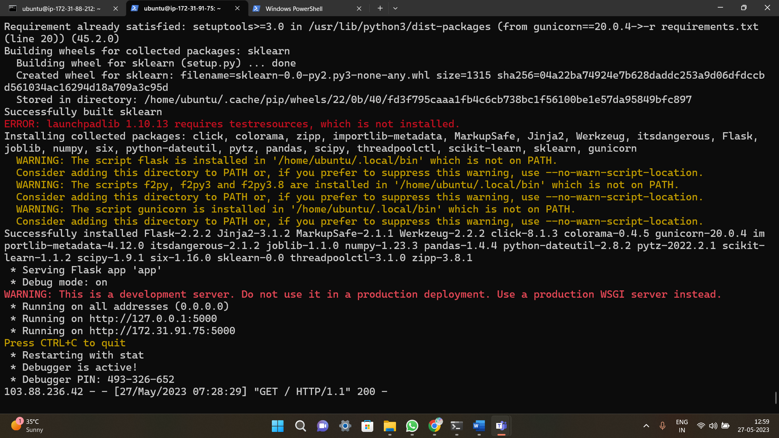

* Copy the public ip4 and browse it ip4:port

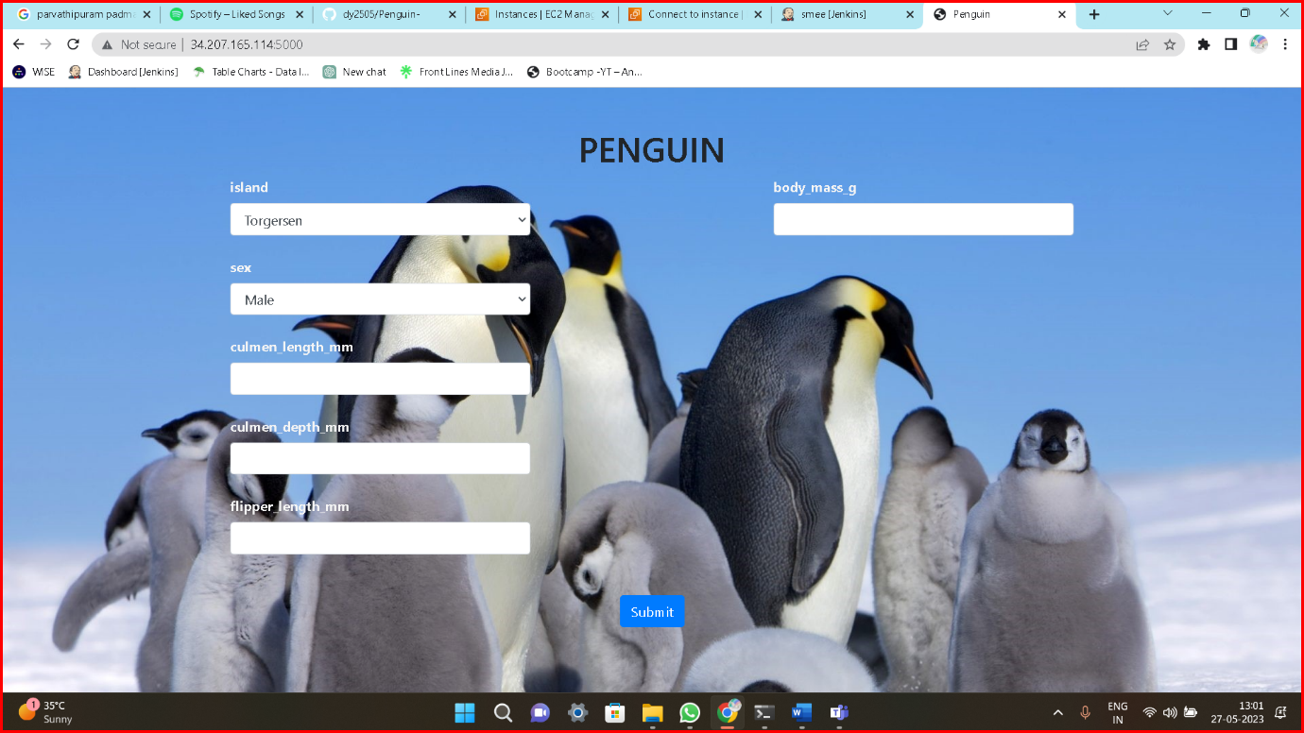

**Method5: Terraform**

* Create an Ec2 instance and connect the terminal
* Inside ubuntu install terraform by using some commands and also create a vpc and inside vpc create internet gateway, route table, subnets, security group by using terraform script and also create ec2 instance.
* Inside ec2 instance create userdata.sh file and enter data.
* **Provider file**

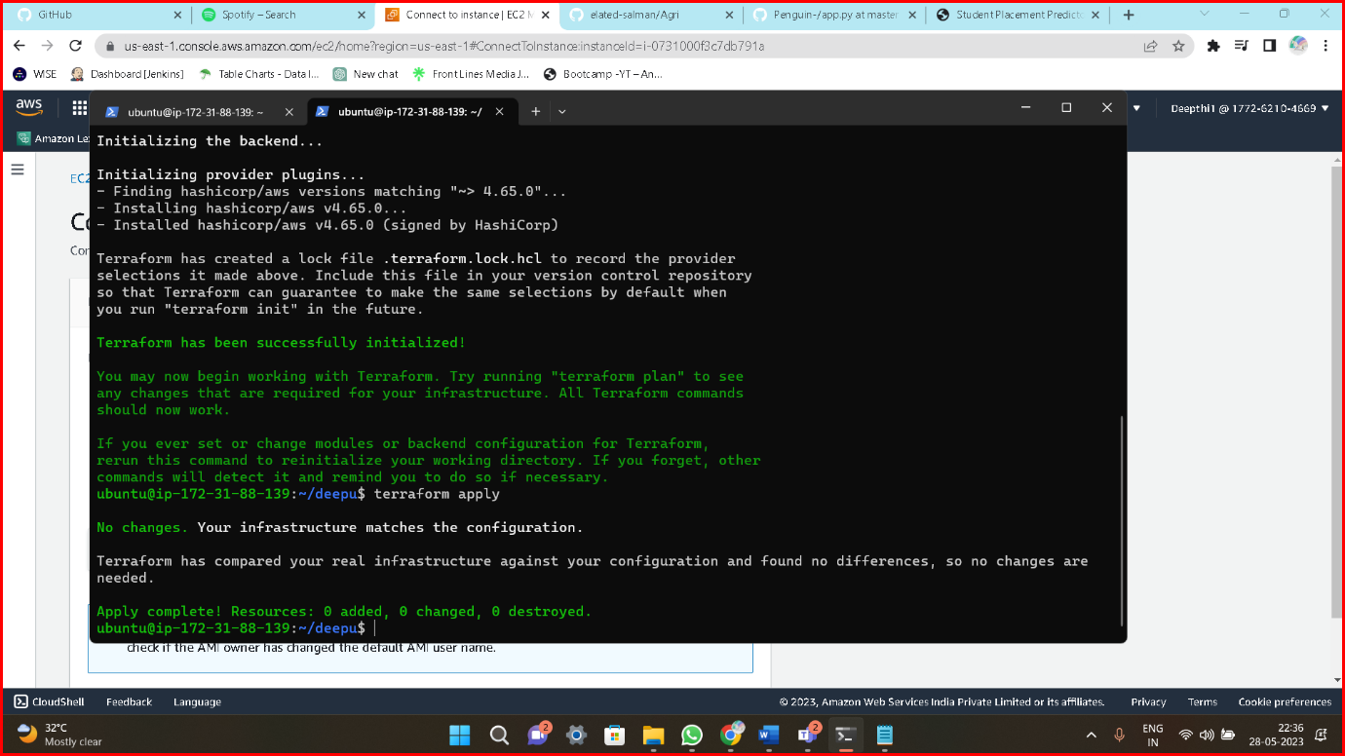

* **Vpc**

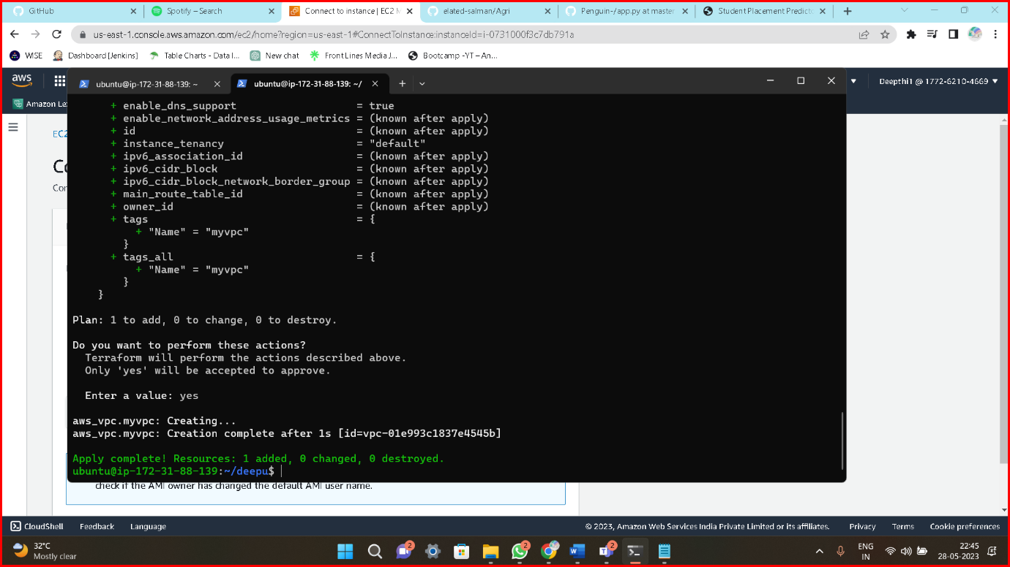

* **Internet gateway**

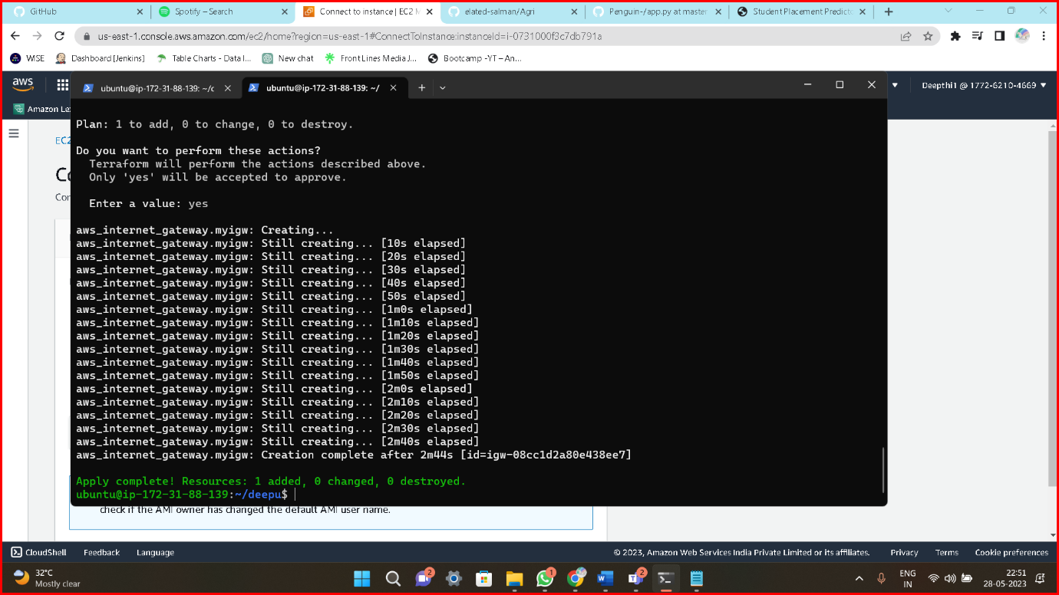

* **Subnets**

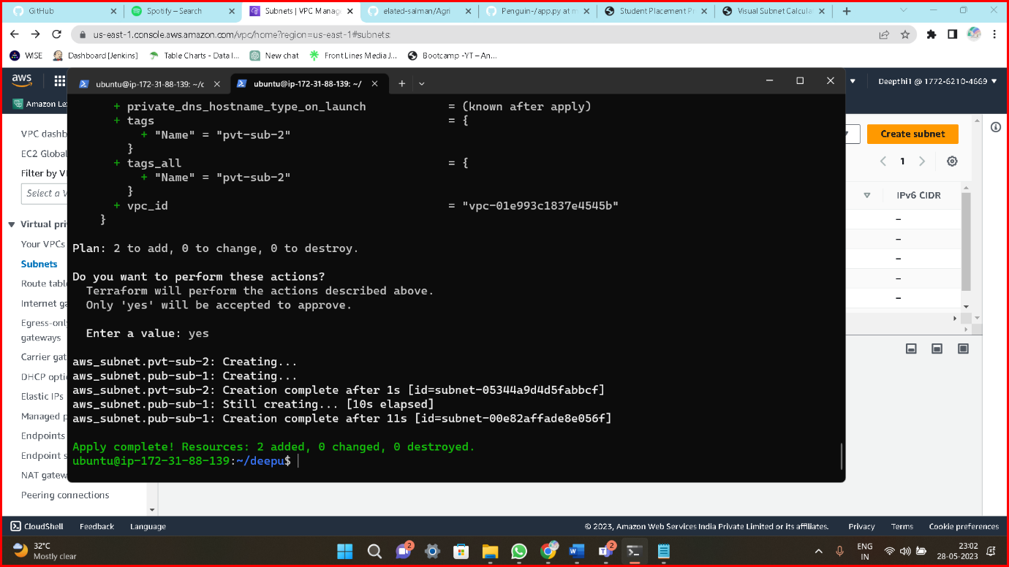

* **Route table**

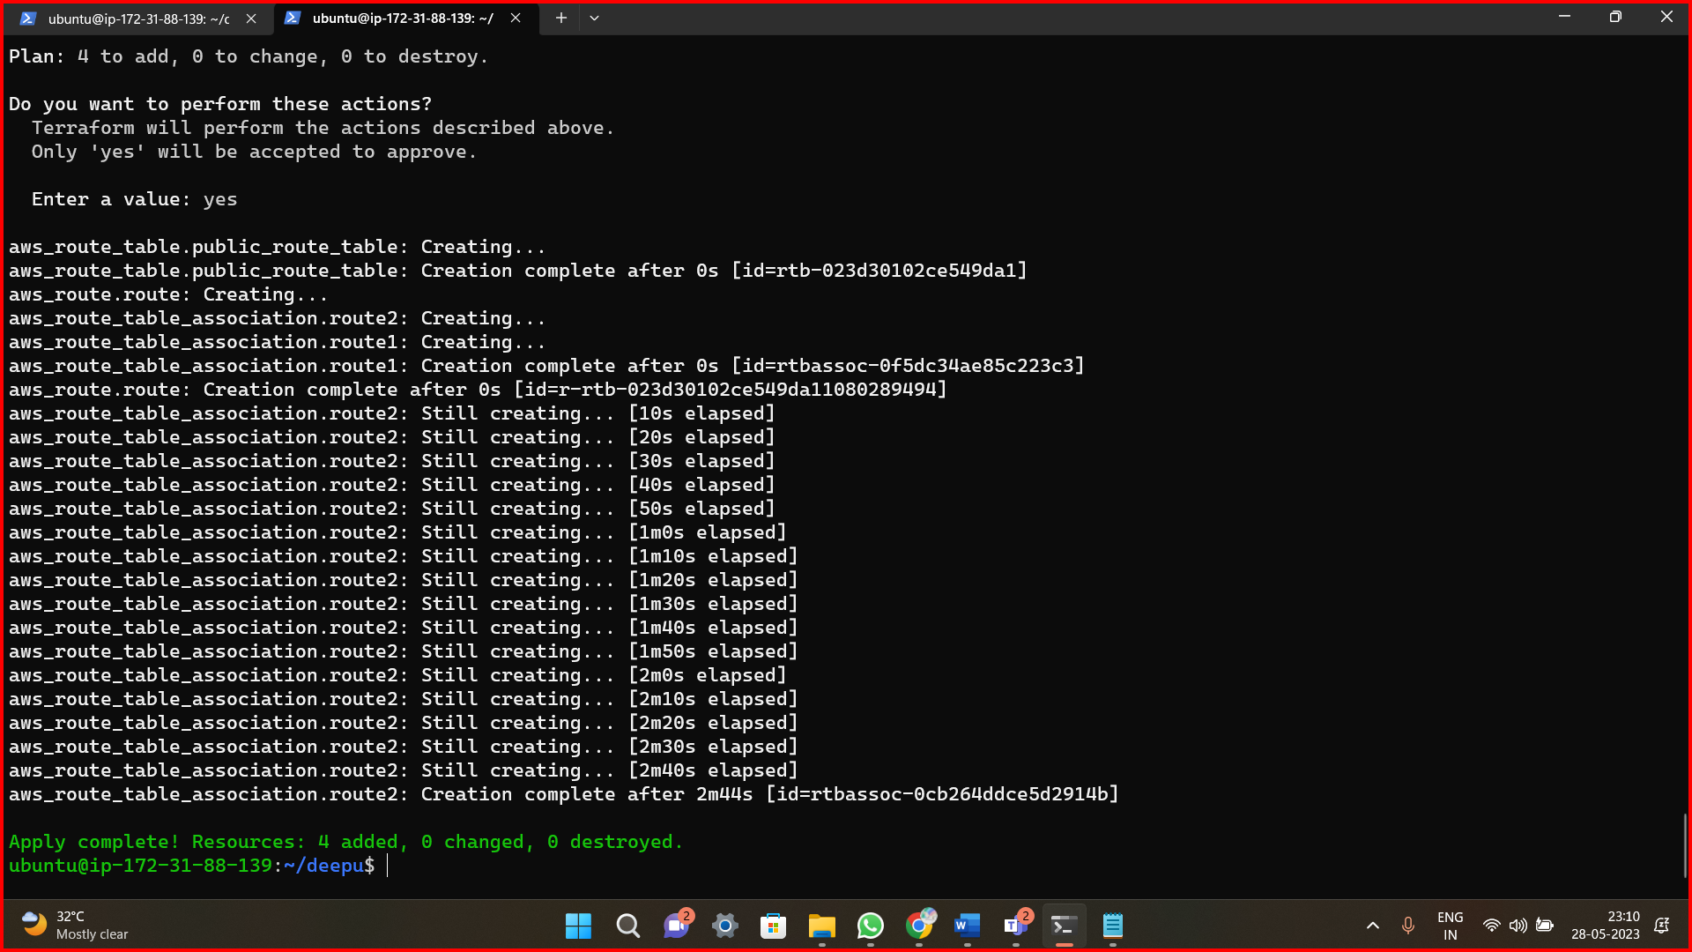

* **Security group**

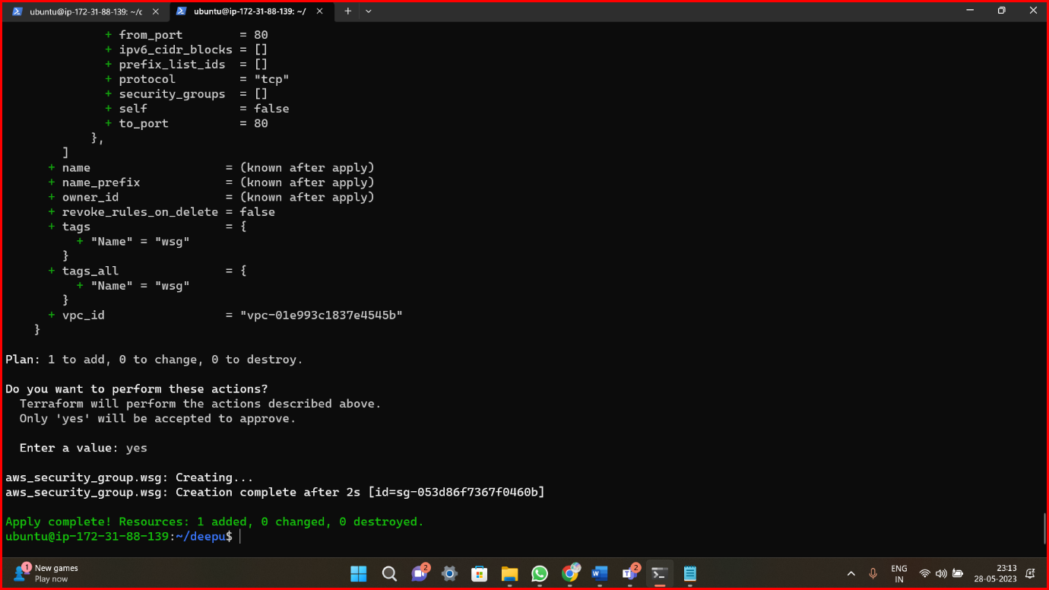

* **Ec2**

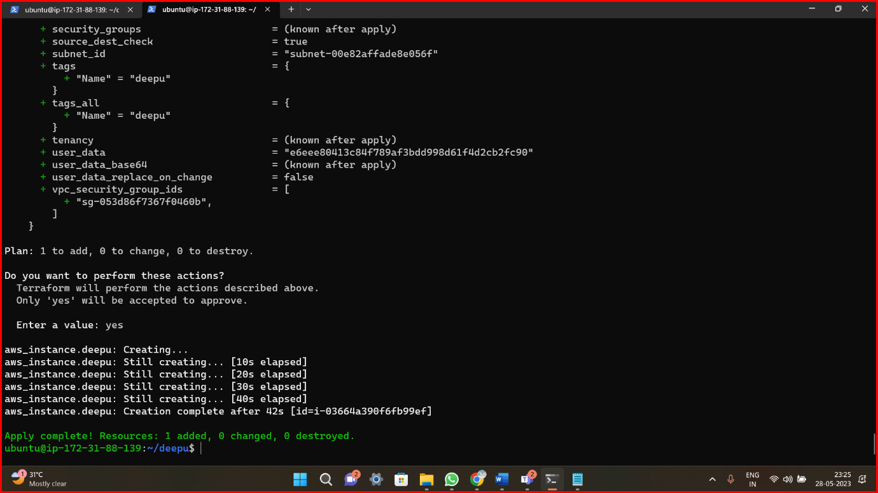

* **Userdata.sh**



* Now wait for 2/2 check pass

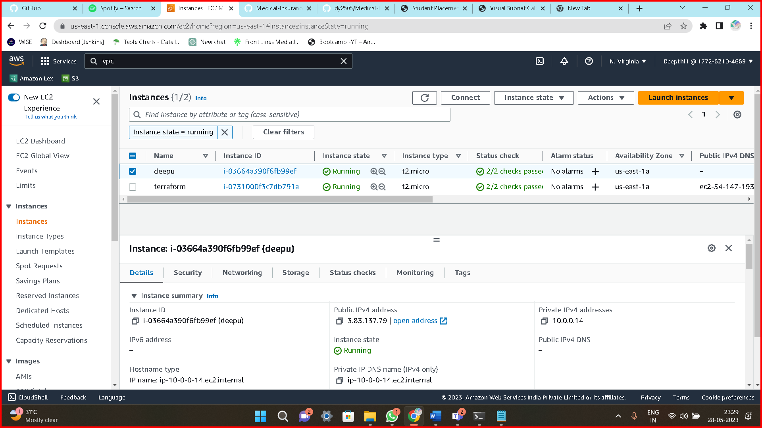

* Copy the public ip4 and browse it ip4:port

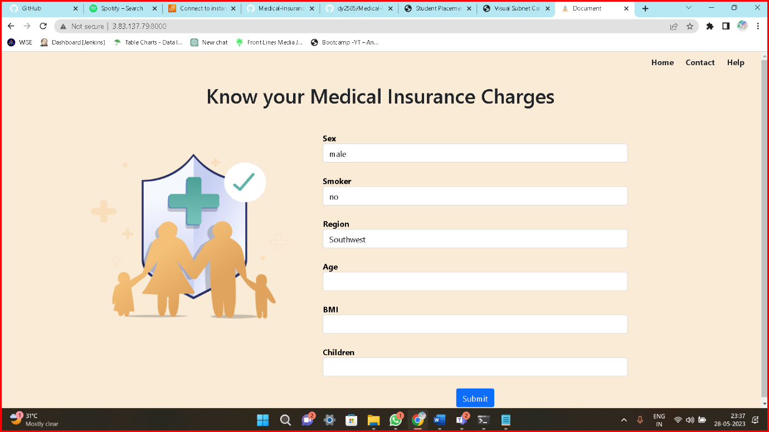

* After destroy all the components what you are created otherwise it will charge

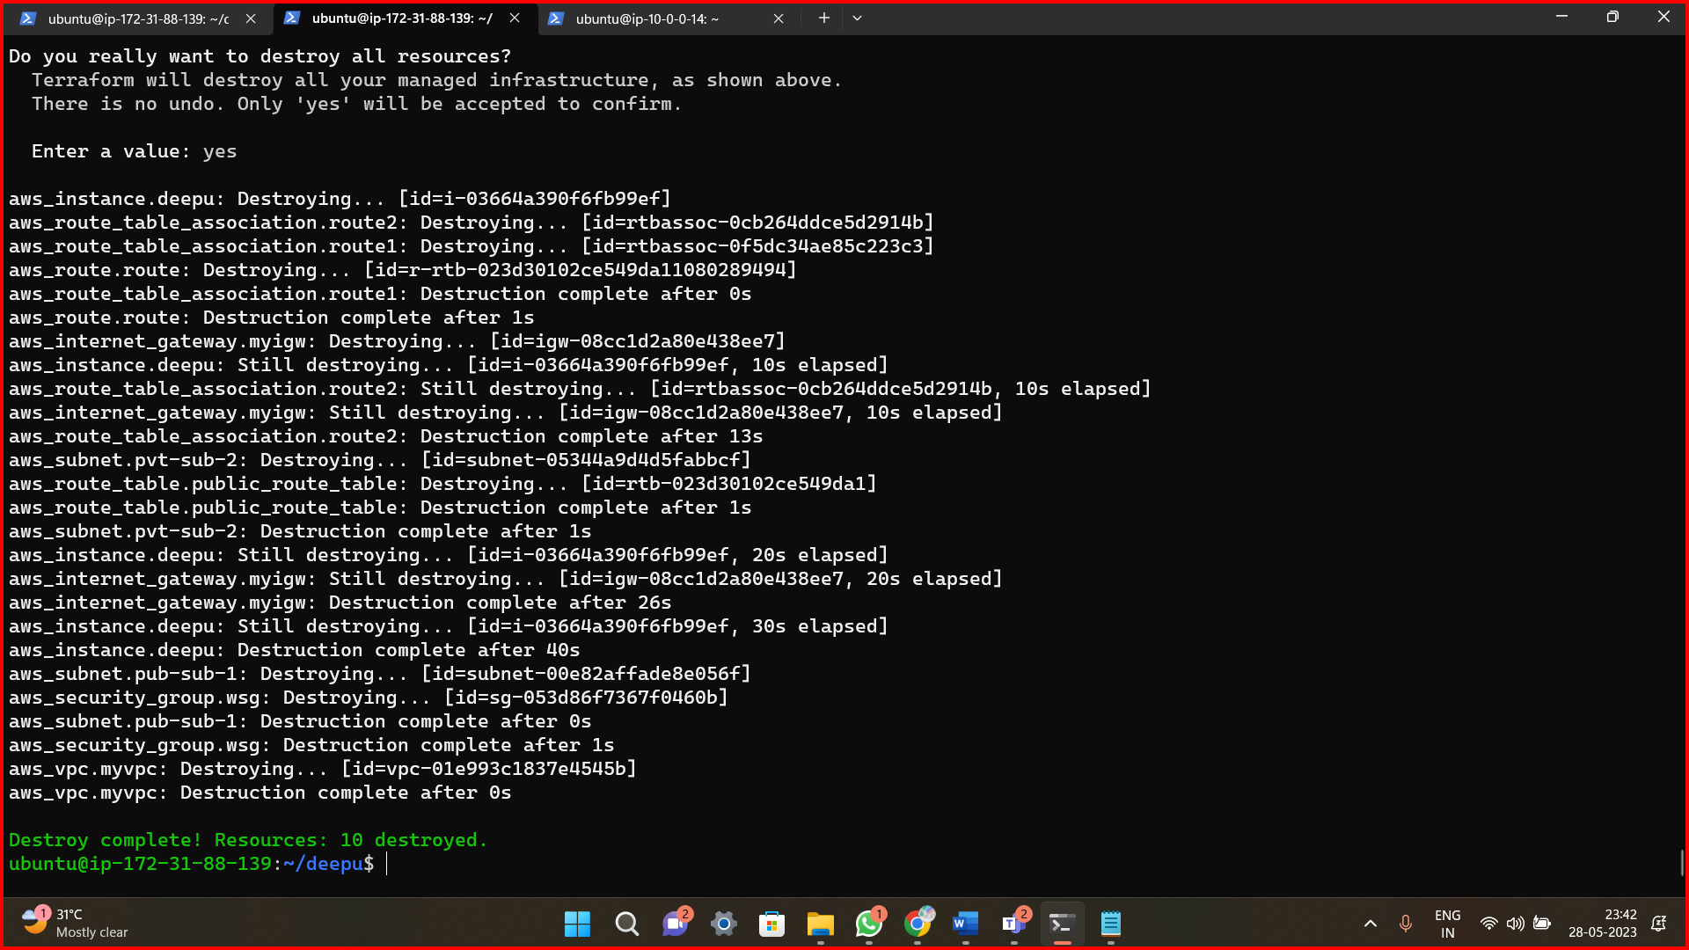

**Method6: Jenkins & Userdata.sh**

* Create an Ec2 instance, connect to the terminal and install Jenkins service and start and enable the service

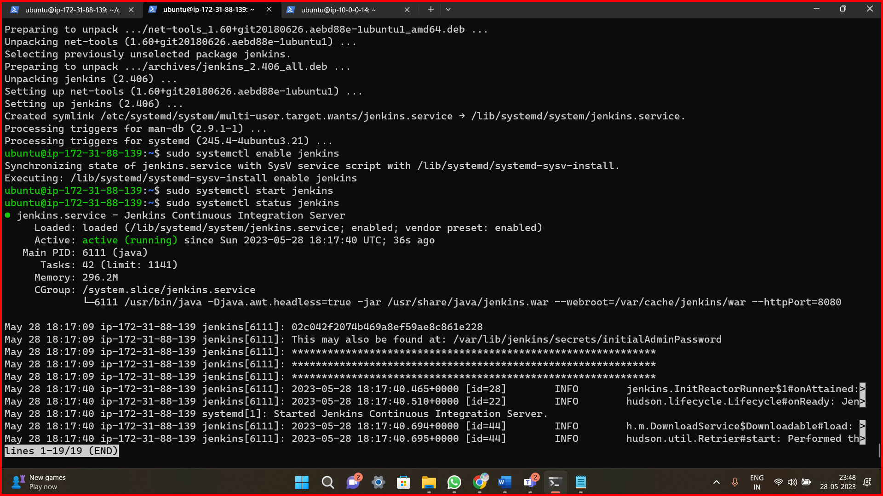

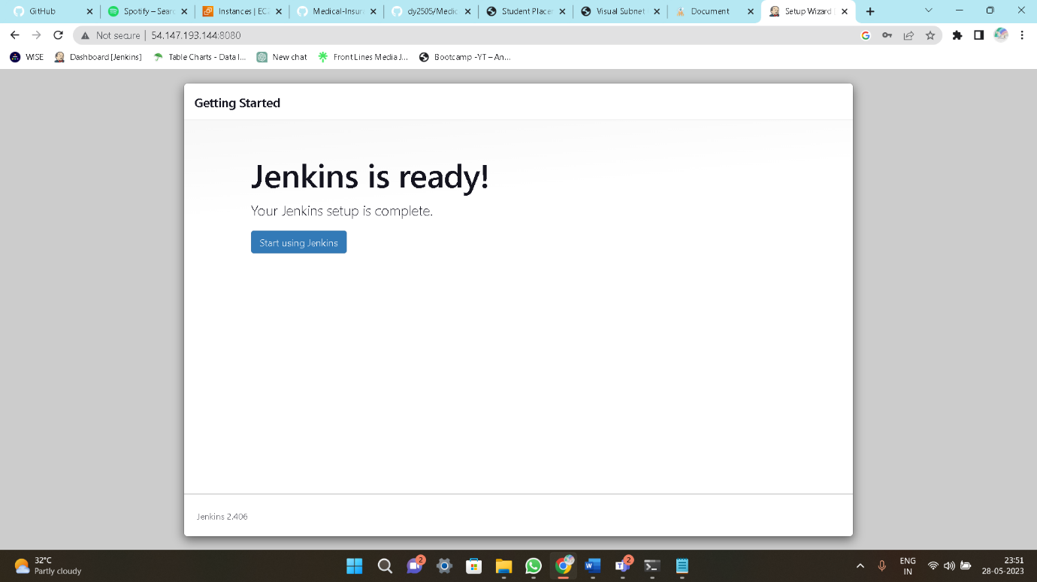

* Now create a free style project and in execute shell add the commands to deploy python application.

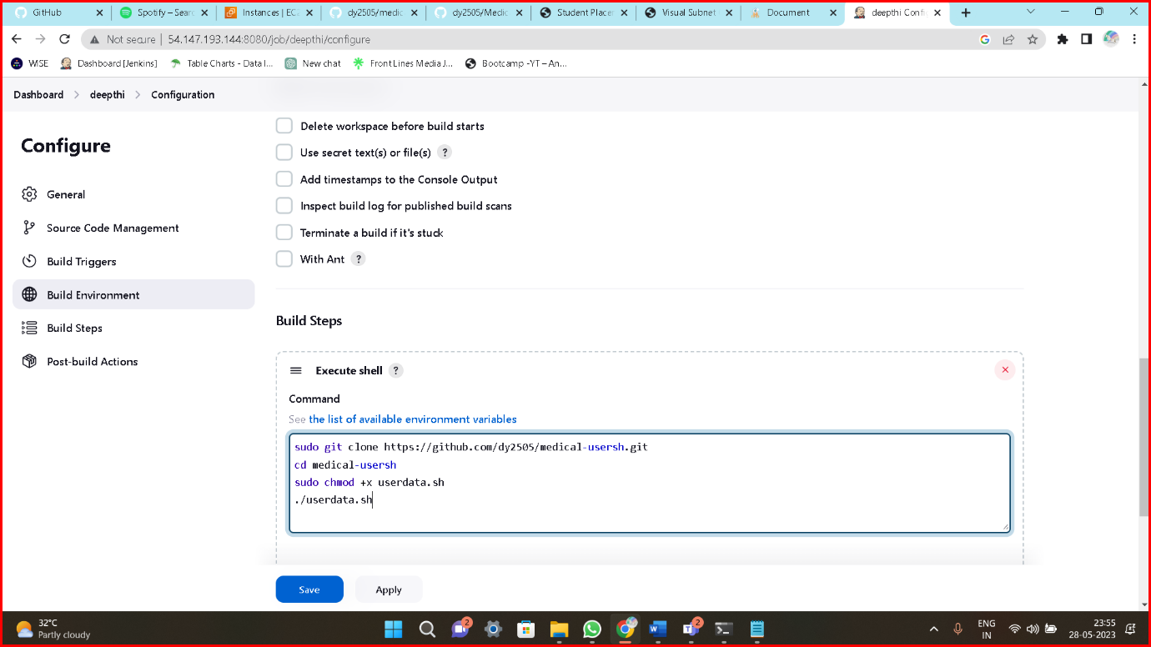

* Give sudores permission, **jeniks ALL=NOPASS:ALL**

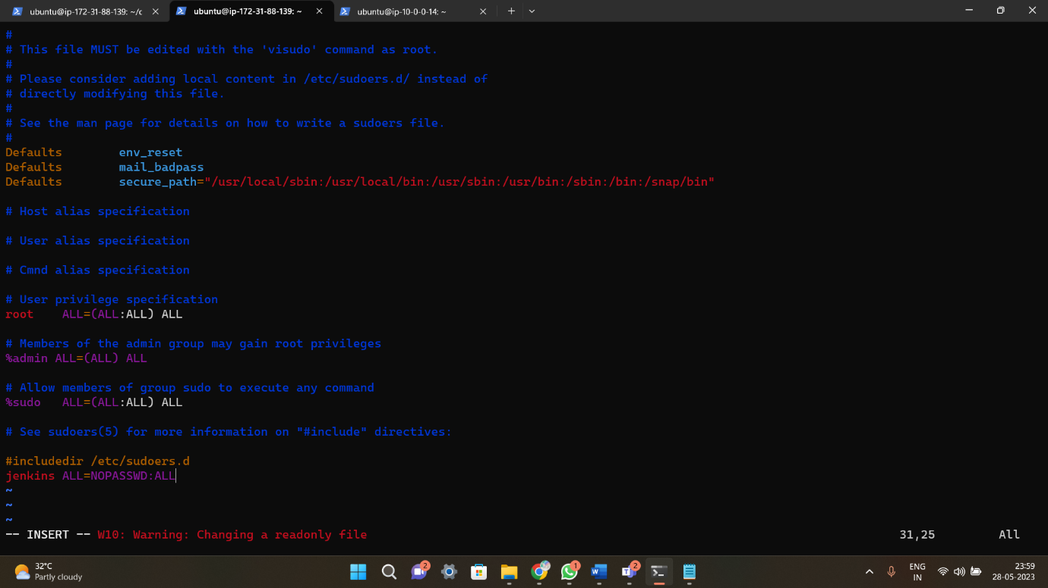

* After build ,its successfully build now.

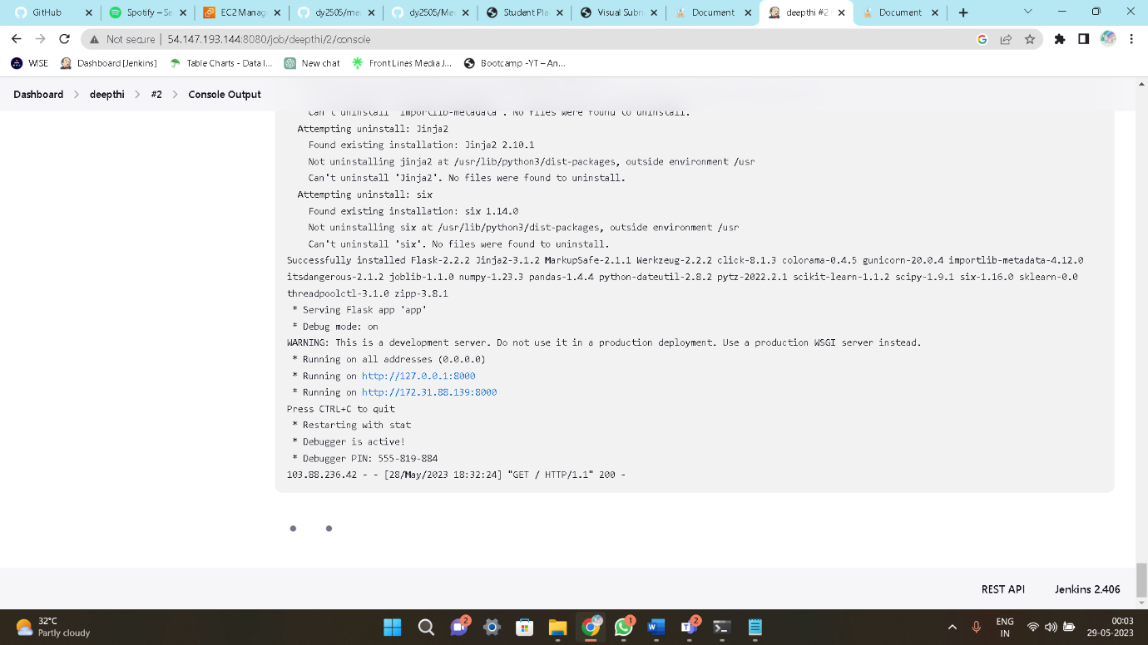

* Copy the public ip4 and browse it ip4:port

